GU LIVE SAFE

(MOBILE APPLICATION TO ACCESS THE SECURITY SERVICE PROVIDED BY GANNON POLICE)

Plan B – Technical project

To be presented on *[4/29/2016]*

***DINESHARUMUGAM SENTHIL ARUMUGAM***

***(Software Engineering)***

***PRASHANTH KUMAR LANKADHASARI***

***(Information Analytics)***

***LESTER L.FETTERMAN***

***Assistant Director***

***Office of Police and Safety***

***(814)871-5678***

***fetterma003@gannon.edu***

Advisor: Dr. STEPHEN T.FREZZA

This proposal is submitted to the Computer and Information Science faculty in partial fulfillment for the degree

Master of Science in Computer and Information Science.

**TABLE OF CONTENTS**

1. Introduction 1

1.1 Problem Statement 1

1.2 Background 1

1.3 Needs STATEMENT 1

1.4 OBJECTIVE 1

2. Proposed TECHNICAL APPROACH 1

2.1 Requirements 1

2.2 Architecture Design 1

2.3 Implementation DESIGN 1

2.4 Quality Assurance Plan 1

3. Expected Project Results 1

3.1 MEASURES of SUCCESS 1

4. Schedule 1

# Introduction

This proposal is for a plan B technical project with retrospect to the partial fulfillment for the degree, Master of Science in Computer and Information Science.

The purpose of this project is to develop a mobile application to access the security service provided by Gannon police. Since Gannon is located in a high crime area in Erie, the Gannon police provide certain services to give safety to students, faculties and staffs. The project’s objective is to develop an application that provides easy access to the Gannon Security services and in turn provides Gannon Police to serve students efficiently. User friendly application deployed in Android and iOS application stores will be developed.

## Problem Statement

|  |  |
| --- | --- |
| Element | Description |
| The problem of ... | People getting into trouble while walking in and around campus arenas. |
| Affects ... | Assaults, harassment, sexual assault etc … |
| And results in ... | Getting serious injuries, loss of life, etc … |
| Benefits of a solution ... | Keeps yourself safe by using this application. |

## Background

Gannon University is in a high crime area of Erie Pennsylvania. Campus is in the city, so distances often need traversed for students, faculty, and staff to arrive at their destination. Gannon has an escort service called GUEST where users can request an escort in person, by a phone call to Police and Safety, or, newly, by texting a number. The GUEST service is vastly under-utilized by the campus community. Students have a perception of low safety, but still do not use the service.

## Needs STATEMENT

Gannon police and safety department offers security services to Gannon students, staff and faculties, it takes several processes and procedures to access these services, therefore Gannon police and safety department wants an application for students, faculties and staffs to access these services. By using this application the offered services can be accessed easily and increases more safety and security to Gannon students, faculties and staffs.

## OBJECTIVE

* Building an GU Live Safe mobile multi-platform app that
  + Increases campus utilization of escort and shuttle service.
  + Increase student, faculty and staff perception of safety on campus via survey matrices.
  + Increase ease of management for switchboard operator.

# Proposed TECHNICAL APPROACH

Technical approach intended for project as follows

* + Project initiation is done gathering requirements for the app to be developed.
  + The app that is capable of being put under deployment through PhoneGap is designed.
  + Small incremental release phases are planned and iterated.

## Requirements

* The app should be designed in a way that it is compatible with the PhoneGap for being deployed into the mobile platforms (Android and iOS).
* **The context diagram and use case diagram:** to identify objects outside the system that connect to it.
* **Storyboards and low- fidelity prototypes:** to flesh out the dialog map by showing what each screen will contain without depicting precise details. Display- action-response models describe the display and behavior requirements of each screen.(Because it is a mobile app)
* **Flowcharts and activity diagrams:** to visually depict the flow of the use case dialog and branches into alternative flows and exceptions.
* **Class diagrams:** toshow the logical connections between object classes and the data associated with them.

## Architecture Design

SWITCHBOARD

SECURITY SERVICES

DATA BASE

APPLICATION

GPS LOCATION

LOGIN INFO

REQURST MESSAGES

INFORMATION REPORTING

GOOGLE MAP API

WEB SERVER

## Implementation DESIGN

Overall Implementation:

CLIENT SIDE

MOBILE APPLICATION

SERVER SIDE

SERVER AND DATABASE

Module 1: Development of the application

The user interface for the app is designed using HTML, JavaScript and CSS. PhoneGap is used for the user side development cycle.

**MOBILE APPLICATION**

Application home screen

Log in and authorization

Redirect to home screen

Yes

No

Users

Basic User (Client)

Admin User (Switchboard)

Send request, information and location

Receive request, information and location

Log out / Exit application

**SERVER AND DATABASE**

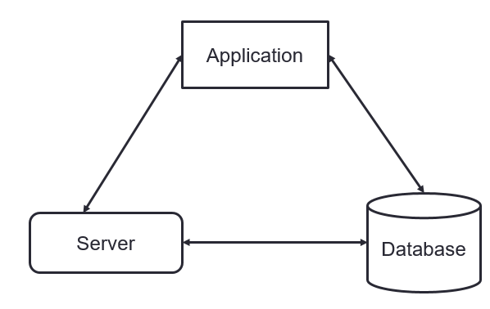

## Quality Assurance Plan

* A constant track of code in maintained and tested to make sure the code is working properly.
* Usability testing is used to check the ease of application prototype.
* Testing done to make sure the database is secured.

# Expected Project Results

* Student being able to download the app.
* Student is able to access (login) the app.
* Student being able to request an escort.
* Student is able to cancel or reschedule an escort request.
* Switchboard is able to receive an escort request anytime.
* Switchboard is able to access and view any request for an escort.
* Students being able to request for shuttle service.
* Students being able to request for virtual watch.
* Switchboard is able to escort virtually.
* Student being able to report crime/emergencies.
* Switchboard is able to receive the crime/emergencies report.
* The Database is delivered.
* Data stored is secured and protected.
* App is integrated and deployed in the server.
* Server able to provide requested services to the client.
* Server able to test, run and debug any problem.

## MEASURES of SUCCESS

* 30% increase in utilization of security service occurs within 3 months of deployment.

# Schedule